**Project on Tableau 10**

**Sales Performance Analysis**

DESCRIPTION

Background

Mike Goodman, the head of Product Management of a retail products company, is responsible for determining which products his company should continue to offer for sale and which products should be discontinued from the company’s product catalog.

Objective

To build a dashboard that will present monthly sales performance by product segment and product category to help client identifying the segments and categories that have met or exceeded their sales targets, as well as those that have not met their sales targets.

Domain: Ecommerce

Dataset Description

We will be using two datasets here i.e. [Sample - Superstore and Sales_Target](https://github.com/Simplilearn-Edu/Tableau-10).

Analysis Tasks

1. Use the Saved Sample – Superstore dataset.
2. Create a bullet chart with Category and Segment dimensions and Sales measures.
3. Blend the data with the Saved Sample - Sales Target data set to bring in the Sales Target measure.
4. Color code the chart to identify Categories and Segments that are above or below target.
5. Add the year of sales to the view to identify trends and outliers.
6. Add a filter so that the user can select one, more than one, or all years.
7. Create a dashboard with this view.

Following step to be needed to complete above description presentation are:

STEP 1. : Connect to the databases

* Open tableau,.
* As we have our provided database in Microsoft Excel, so click on Microsoft Excel on left pane To a file pane.
* Select Excel file name Sample – Superstore.xls
* In the opened connection pane will pop up select/drag order sheets from the sheets sub pane to right , sheet database will open.
* Similar way click on data menu , click on add new data source, select Microsoft Excel and select Sales_Target.xls file.
* Both file will open in data pane.

STEP 2.: Add Sheet for representation

* Select sheet1 at down foot of the opened tableau.
* From the Data pane in left side ,select order datasheet
* Details of table fields and measuring fields will populate in left side pane
* Drag order date fields in Rows space In the opened sheet. Detail will show in year
* Click on the order date fields in Rows, a window will pop up, select month the it and check discrete is selected.
* As soon pop up window close the year representation will shown in months now.
* Drag segment field from left pane to rows space In the opened sheet , detail will populate in the sheet1 representation space.
* Drag category field from left pane to column space, detil will populate in the representation area.
* Drag measure field sales in columns area, it comes as sum(sales) here.
* Change by selecting database sales target.
* Drag sales target(sales target) field to detail button on marks
* To make effect this field we have to add reference line from the footer of representation area.
* Right click on the footer of representation report, select add reference line.
* In the open window select per cell in scope area.
* In the value combo box select sum(sales target(sales target)).
* In label combobox select None.
* In formatting select size of line and color of target line, click ok.
* Click to Add calculated field.
* In the open window give name of the calculated field sales_ab_budg.
* In the formula are wirte

If sum(sales)>=sum(sales target(sales target))

Then ‘above target’

Else ‘below target’

End

* Click apply and click ok.
* After creating calculated field drag it to colour button, target will shown in pop up area in the representation.
* In the right side pane two ABOVE TARGET AND BELOW TARGET with colors with shown , to change color click on header of these and change colors.
* Now add filter of years drag order date to the filter pane . In the right pane list of years will pop up with checkbox for selection.
* Select the database sales target, drag field order date to detail button , now the representation will comes what we select the year in right pane.
* Add a dashboard, add this sheet1 representation to dashboard.
* In left pane of the dashboard select size range to automatic.
* Whole representation with take area to screen.
* Change the title of the dashboard and save it to tableau server and the out put likes

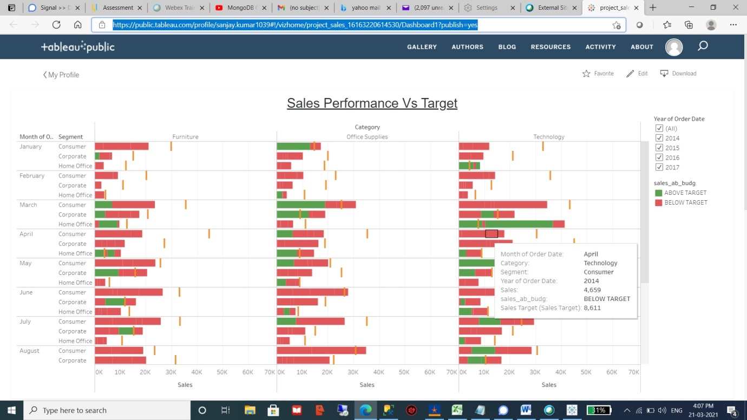

Path to check represtation report:

https://public.tableau.com/profile/sanjay.kumar1039#!/vizhome/project_sales_16163220614530/Dashboard1?publish=yes